Raising awareness that suicide is a public health issue
Missouri SPAN
Legislative
Update

Missouri Suicide Prevention Network 1/12/2021
Missouri lawmakers returned to Jefferson City for the start of the 2021 session
Members of the Missouri General Assembly return to the State Capitol for the start of the 2021 legislative session, which officially began at noon on Wednesday, Jan. 6. The 2021 legislative session marks the beginning of the 101st General Assembly.

The Missouri Suicide Prevention Network has created Missouri SPAN as a way to gain support for suicide prevention advancement. During session, our team will keep you informed of proposed legislation and opportunities to engage lawmakers.

Here are the 2021 Regular Session bills we are monitoring
Bill # | Sponsor | Last Action | Summary
HB170 | Rep. Ellebracht (Clay county) | 1/07/2021 - Read Second Time (H) | Provides that a person may be charged with promoting a suicide attempt or voluntary manslaughter if such person is convicted of abusing certain persons and such conduct significantly contributed to the suicide or suicide attempt
HB304 | Rep. Kelley  (Jade, Barton, Jasper, Cedar counties) | 1/07/2021 - Read Second Time (H) | Enacts requirements relating to suicide prevention education and information
HB437 | Rep. Appelbaum  (St Louis county) | 1/07/2021 - Read Second Time (H) | Enacts requirements relating to suicide prevention education and information
HB465 | Rep. Pike  (Vernon, Bates counties) | 1/07/2021 - Read Second Time (H) | Enacts requirements relating to suicide prevention education and information

What does “Read Second Time” mean?
Our Suicide Prevention Advocacy Handbook explains the Missouri legislative process, how you can create change, and more. Visit our webpage at www.mospn.org/missourispan and download for free!

Be sure to follow us on Facebook and Twitter for news and information about suicide prevention.

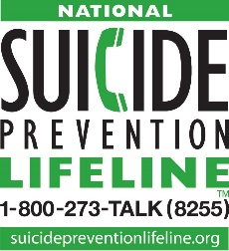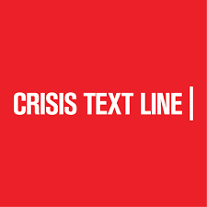
Veterans Press 1 Text MOSAFE to 741741

